Our Ref: _______________ Your Ref: ________________________ Date: __________________

Baptist Church

Baale Yaku Site Area, P. O. Box 644,

Ogbomoso, Oyo State. Tel. 07052425407

Email: [newsprinbaptistchurch@gmail.com](mailto:newsprinbaptistchurch@gmail.com)

Website: newspringbc.comze.com

NEW SPRING

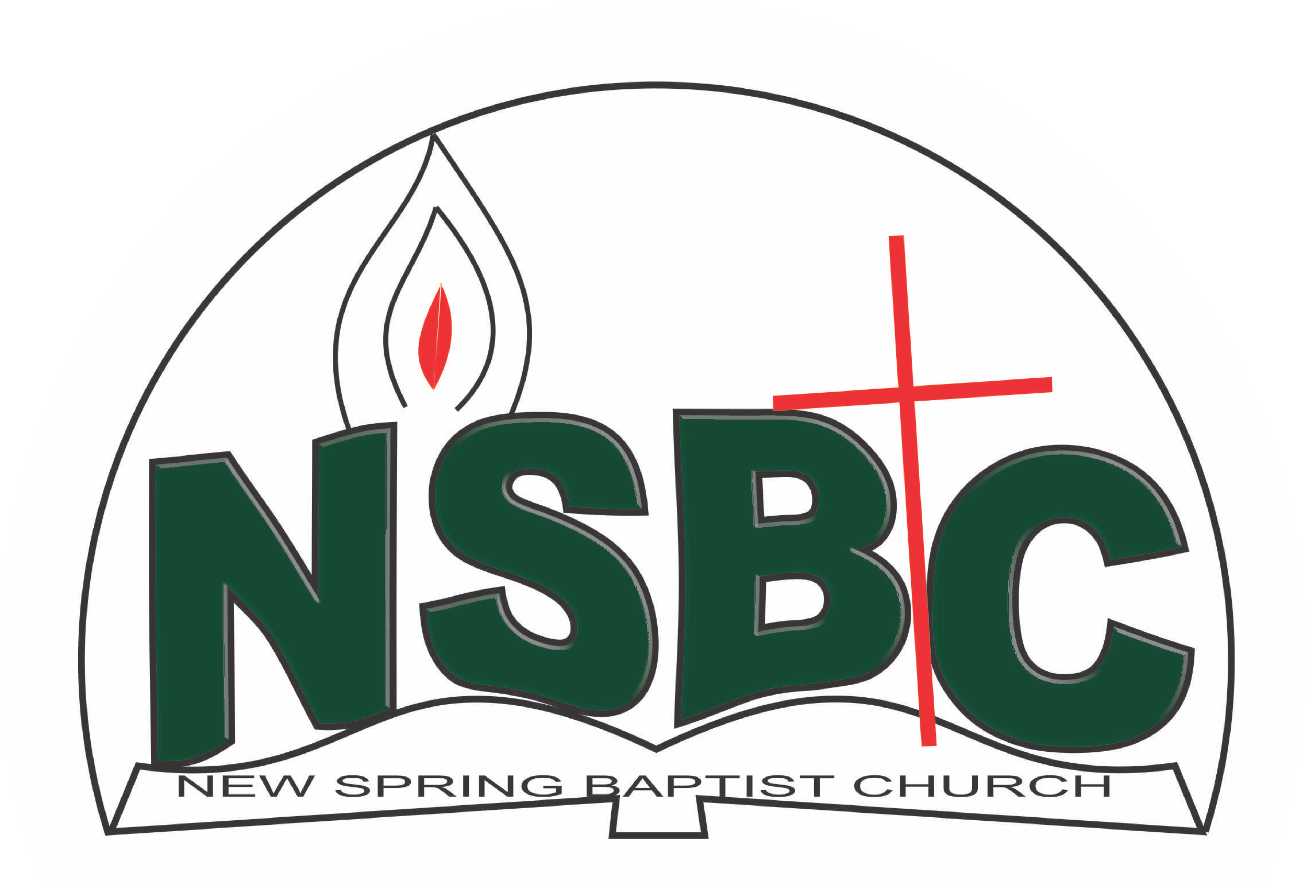

December 27, 2021

Dear Mrs. Bose Alamu,

Nomination to Serve as a Worker in the Church in 2022.

Calvary greetings in the precious name of our Lord and Saviour Jesus Christ. It is our pleasure to inform you that at the Church-in-Conference held on December 19, 2021; the Church ratified your nomination to serve in the following areas between January 1 and December 31, 2022:

1. Choir Director under the chairmanship of Pastor Seun Olabode
2. Member, Church History Committee under the chairmanship of Mr. Yemi Alamu
3. Financial Secretary
4. Member, Benevolence Committee under the chairmanship of Dn Dele Olatubosun
5. Member, Stewardship Committee under the chairmanship of Mrs. Nia Olupona
6. Member, Church Council

Please refer to the table below for the key functions of each of these roles. Details can be found in the Church constitution. You are strongly encouraged to become familiar with the tasks as stated in the document. There will be an orientation of the Church workers on January 15, 2022 at 8:30 a.m. on the church premises. Please ensure you participate in this training.

“Now it is required that those who have been given a trust must prove faithful. I Corinthians 4:2”. May God find you faithful in the task He has assigned to you.

| Domain | Key function of Office, Department or Committee |
| --- | --- |
| Music Ministry | Responsible for the music component of the Church’s worship and other programmes. |
| Church History Committee | The purpose of the committee is to document past and current key events in a systematic manner so that the evolution of the Church can be understood when her history is reviewed in the future |
| Financial Secretary | To provide support to the Church Pastor in ensuring correct and accurate record of all monies received by the Church for effective ministry |
| Benevolence Committee | The committee is responsible for the implementation of the benevolence policy of the Church |
|  |  |
| Stewardship Committee | The committee is responsible for the overall management of the Church’s fiscal policy |
| Church Council | It is the governing body of the Church whose membership, under the leadership of the Holy Spirit, holds one another mutually accountable with respect and love and see to the smooth running of the Church |

Thank you for accepting to serve in this Church.

Yours in His service

Olusayo Okediji Blessed Agboola

Church Secretary Chairman, Nominating Committee